ITEM NO | : | 4.2
SUBJECT | : | Gladesville Masterplan Planning Proposal
STRATEGIC OUTCOME | : | Neighbourhoods reflect local character, heritage and create a sense of belonging
ACTION | : | Implement recommendations from the Local Strategic Planning Statement (LSPS)
REPORTING OFFICER | : | Kieran Metcalfe

Ref:760425

PURPOSE

The purpose of this report is to seek Council’s consideration of the merits of a Council initiated Planning Proposal (PP) relating to the implementation of the Gladesville Masterplan project.

The PP seeks to deliver on the objectives of the Gladesville Masterplan project through amendment of the Hunters Hill Local Environmental Plan 2012 (LEP) in accordance with the Hunters Hill Local Strategic Planning Statement (LSPS) and Local Housing Strategy (LHS).

This report provides a recommendation to Council to forward the attached PP to the Minister for Planning and Public Spaces (through the Department of Planning, Housing and Infrastructure) seeking a Gateway Determination in accordance with 3.34(1) of the Environmental Planning and Assessment Act 1979. A subsequent Gateway Determination would facilitate future stages of planning, assessment and consultation associated with the PP, including formal community consultation.

RECOMMENDATION
- That Council supports the recommendations set out below:

- Forward the Planning Proposal included as Attachment 1 to this report to the Department of Planning, Housing and Infrastructure seeking a Gateway Determination in accordance with section 3.34 of the Environmental Planning and Assessment Act 1979.
- Subject to (A) above, Council endorse for public exhibition the Planning Proposal as outlined in (A).

- Note that following public exhibition, the Planning Proposal would be reported back to Council detailing the outcome of the public exhibition period at which time Council may resolve:

(1) To proceed as recommended in this report.

(2) To proceed with amended controls in the Planning Proposal to that exhibited.

(3) To not proceed with the Planning Proposal.

(D) Delegate authority to the General Manager to make amendments to the Planning Proposal that:

(1) Are minor and do not alter the intent; or
(2) Are required in order to comply with the Gateway Determination.

Background

Location and Property Description

The Gladesville Masterplan Planning Proposal site is located within the Gladesville Town Centre. The locality of the site is illustrated within Figure 1 below.

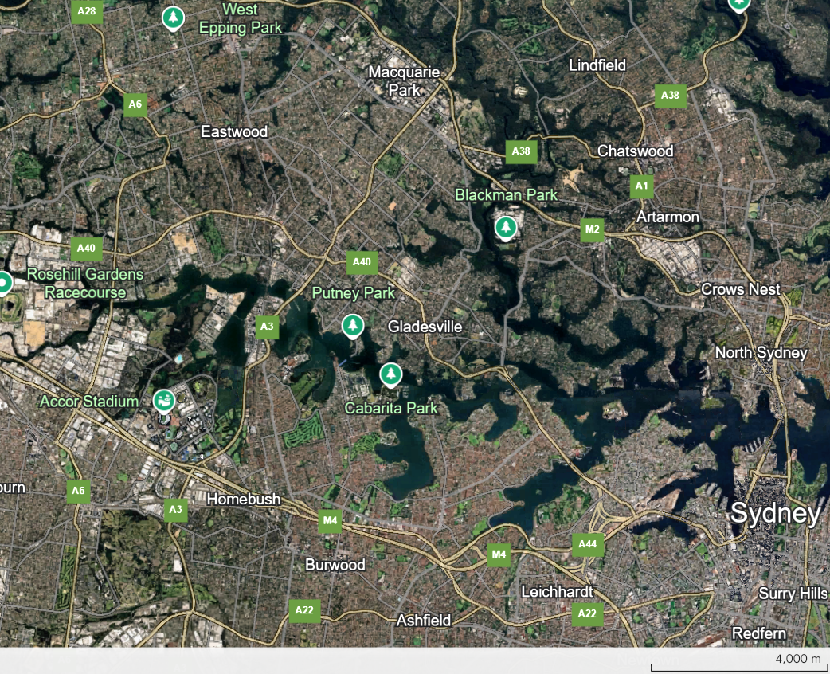
Subject Site
Figure 1 – Site Locality (source: adapted from Google Earth, 2025)

The Gladesville Masterplan planning proposal investigation area initially included 4 separate blocks (referred to as Blocks 1 - 4) fronting Victoria Road in Gladesville as illustrated within Figure 2 below. However, in consideration of factors such as economic feasibility, heritage, lot configuration and existing local environmental plan (LEP) provisions applying the area (as discussed within this document) the investigation area considered within this Planning Proposal was refined to include only Block 4.

Block 4 (the Planning Proposal Site or Site) has an area of approximately 13,850 square metres and incorporates the Gladesville Shopping Village and several nearby properties. The Site adjoins Victoria Road to the west, Massey Street to the north, Flagstaff Street to the east and Cowell Street to the south. The Planning Proposal Site (outlined and shaded in red and labelled ‘Block 4’) is illustrated within Figure 2 below.

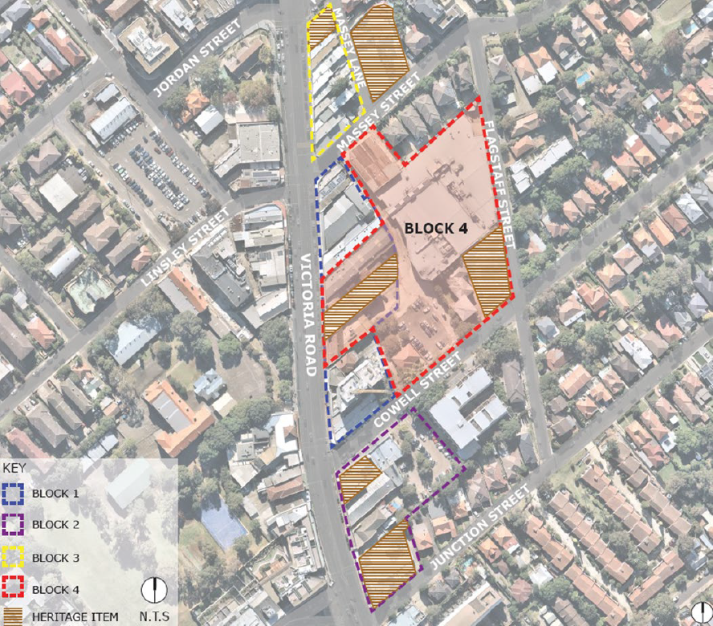
Figure 2 – Planning Proposal Site (outlined and shaded in red and labelled ‘Block 4’)

History of the Gladesville Masterplan Project

As noted above, the Gladesville Masterplan planning proposal investigation area initially included 4 separate blocks. Council has previously prepared development plans for these 4 blocks to inform the Gladesville Masterplan Project (the Project). The block plans were not fully worked up architectural/urban design plans and adjustments to the block options and further refinement of the building envelopes has been required. In addition to urban design work, initial economic feasibility analysis was undertaken and a traffic study prepared.

The approach taken by Council, including initial economic, traffic and urban design investigations, provided the foundations for driving change and market interest in re-developing and updating the Gladesville Town Centre for the public benefit, rather than development interest alone. This was in response to community sentiment about the poor presentation of the town centre, variable trading performance and delayed renewal of properties, following consultation with land and business owners, as well as interested stakeholders.

On 19 July 2021, Council Resolved to place draft plans and studies for Blocks 1, 2 and 3 and draft Concept Block Plans for Block 4 on public exhibition for a period of 28 days. Council also Resolved that a report be prepared for Council with an assessment of any submissions received and recommendations for the finalisation of the Gladesville Masterplan. The draft Block Studies were subsequently placed on public exhibition from 5 August until 17 September 2021.

It was clear from the feedback from the consultation process that the renewal of the Gladesville Town Centre is important for local residents. The feedback indicated that the community would like to see well designed buildings, increased public open space and a new supermarket with associated retail. The community is also keen to see a vibrant night-economy, improved pedestrian connectivity and increased community facilities.

Whilst initial technical plans and studies were prepared to inform the previous block studies and to facilitate initial community consultation, in order to achieve the outcomes of the Project, changes to planning controls under the LEP are required. These changes are required as planning controls currently in place prohibit many of the envisaged outcomes of the Project, such as increased height of buildings and increased development floor space. These planning controls are proposed to be amended through a Planning Proposal applying to Block 4 (the Proposal). This Planning Proposal has been sought to meet the requirements to amend an LEP under Part 3 of the Environmental Planning and Assessment Act 1979 and the NSW Government’s LEP Making Guideline. This more detailed assessment and planning has built upon and not superseded previous work undertaken to inform the Project.

This matter was most recently reported to Council’s Ordinary Meeting of 27 November 2023, where an indicative program and resourcing structure to deliver the Project was considered. At this meeting Council unanimously Resolved:

…2. That Council endorses the implementation of the Council led planning proposal investigations to facilitate the implementation of the Gladesville Masterplan project...

This Planning Proposal has been prepared as a result of the above Resolution of Council, and builds upon previous work undertaken in relation to the Gladesville Masterplan Project.

REPORT

Project Scope

Subsequent to the abovementioned Resolution of 27 November 2023, Council Staff confirmed the scope of the Planning Proposal (including required specialist studies) through the development of a Scoping Proposal in consultation with the NSW Governments Department of Planning, Housing and Infrastructure (DPHI).

Summary of Planning Proposal Investigations

In total, five specialist studies were identified through the Scoping Proposal and subsequent guidance from DPHI as being required in order to inform the Planning Proposal. These incorporated:

- Preliminary site investigation (contaminated land assessment).
- Heritage impact assessment.
- Transport impact assessment.
- Economic and feasibility assessment.
- Masterplan.

A summary of the findings of the specialist investigations used to inform the Planning Proposal are presented under the headings below.

Preliminary site investigation (contaminated land assessment)

The preliminary site investigation (PSI) assessment sought to identify contaminated land constraints within the wider Project area. The PSI made the following conclusions:

- Historical land titles have indicated that the site has been owned by a number of private individuals and companies between 1890 and 2024 for Strata Plan No. 60993. It is considered that there is a low to moderate potential for land contaminating activities to have occurred within the Strata Plan that required further investigation.
- Review of historical aerial imagery has indicated that majority of the site has undergone minimal changes since 1943. The major changes have been observed to Block 4, whereby the current Gladesville Shopping Village was constructed between 1994 and 2004. Some demolition and extensions have been observed within majority of the block or surrounding lots. Based on review of historical aerial imagery at the site, further investigation is warranted.
- A review of publicly available contaminated land databases indicated that the site is not the subject of any licenses, applications, notices under Section 308 of the Protection of the Environment Operations Act 1997. The site is not notified under Section 60 of the Contaminated Land Management Act 1997. The site is not the subject of any notifications under Section 58 of the Contaminated Land Management Act 1997.
- Review of council certification has indicated that the site is not registered as:
- Significantly contaminated land;
- Subject to a management order;
- The subject of an approved voluntary management proposal;
- Subject to an ongoing maintenance order; or
- The subject of a site audit statement.
- Based on the desktop review and site walkover, four (4) potential areas of environmental concern were identified within the site ranging moderate to high risk.
- Based on the assessments undertaken as part of this investigation, the PSI has concluded that the site is suitable for the proposed rezoning outlined within the Gladesville Master Plan, with the future associated redevelopment suitable subject to a Stage 2 Detailed Site Investigation that is required to address the four (4) potential areas of environmental concern (PAEC) prior to redevelopment works commencing.

Based on the conclusions stated above and the background data gathered during the course of this investigation, the PSI recommends the following:

- Undertake a Stage 2 Detailed Site Investigation within the identified potential areas of environmental concern to further characterise potential contamination, and inform whether further management or remediation is required prior to redevelopment works commencing on-site.
- Undertake a hazardous building material survey of the structures present on-site prior to demolition.
- Following removal of hazardous building materials (if identified), a clearance inspection must be undertaken by an appropriately qualified occupational hygienist / SafeWork NSW Licenced Asbestos Assessor.
- A waste classification assessment should be carried out on any soil materials proposed for disposal offsite as per the NSW Environment Protection Authority Waste Classification Guidelines (2014).
- Records of the transport and disposal of any materials off-site should be maintained.

This preliminary site investigation is included as Attachment 5 of the Planning Proposal.

Heritage impact assessment

The initial planning proposal investigation area (inclusive of Blocks 1- 4) contains five heritage items. An additional heritage item also adjoins the site to the north of Massey Street. These heritage items are listed below:

- I480 – 2 Massey Street, Gladesville - “Dunham House”.
- I487 – 263 Victoria Road, Gladesville - former Butcher shop.
- I488 – 219 Victoria Road, Gladesville -former Commonwealth Bank.
- I489 – 197-199 Victoria Road, Gladesville – Shops / Hotel.
- I490 – 173-183 Victoria Road, Gladesville – Shops.
- I514 – 10 Cowell Street, Gladesville – House.

In addition to the above heritage items, the planning proposal investigation area also contains part of a heritage conservation area (Hunters Hill Conservation Area No. 3 – Gladesville Village). Block 4, which is subject to this Planning Proposal, contains two heritage items (Item 1514 ‘House on 10 Cowell Street’ and Item I499 ‘Former Bank Building 219 Victoria Road’) and part of the heritage conservation area. These heritage items and conservation area are illustrated within Figure 3 below.

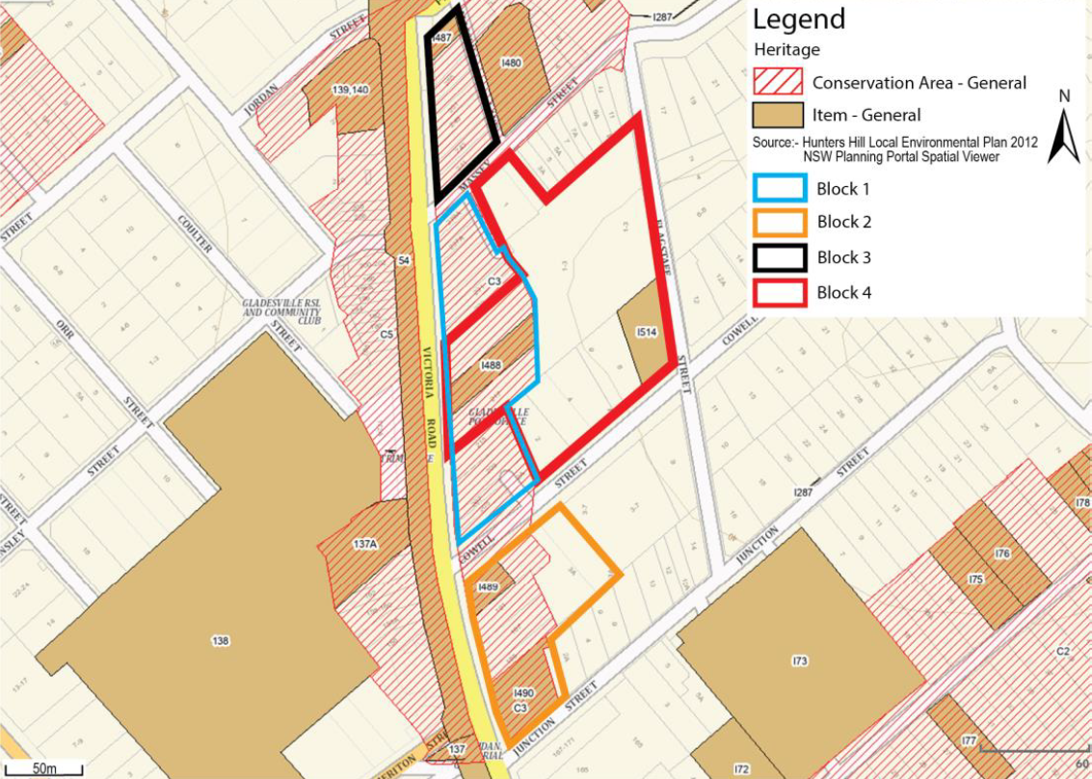
Figure 3 – Heritage Sites within the Project Area

A heritage impact assessment was subsequently undertaken to assess the significance of these sites and to provide recommendations for the management of historic heritage associated with the Proposal.

Recommendations from the heritage impact assessment have been considered in the development of the masterplan included as Attachment 1 to the Planning Proposal and the proposed LEP provisions outlined within Part 2 of the document. Information and recommendations sourced from the heritage impact assessment that are specifically relevant to the Planning Proposal are also summarised under the headings below. Recommendations within the heritage impact assessment that are not specifically relevant to this Proposal will be captured in future reviews of Council’s LEP and Development Control Plan (DCP). The heritage impact assessment is included as Attachment 4 of the Planning Proposal.

Hunters Hill Conservation Area No. 3 – Gladesville Village

Discussion:

It is essential to create a strong differentiation between Block 4, and the properties along Victoria Road. The draft urban design strategy provides a high quality urban space, expanding the existing service lane in places and separating the Victoria Road development from development in Block 4, on the Coles site. The final urban design strategy that accompanies the planning proposal should acknowledge the constraints set by the character and from of the heritage conservation area and the heritage items facing Victoria Road.

Recommendations:

- Retain the consistent parapet line throughout HCA3, including infill development. New development is to be set back a minimum 5 metres from the street frontage to retain parapet lines.

- Encourage site consolidations where possible to achieve better heritage outcomes and quality shop top residential amenity.

Item I488 Former Commonwealth Bank – 219 Victoria Road, Gladesville

Discussion:

There is an opportunity to retain the part of the building that has heritage significance in a development that consolidates sites and places height and density uplifts on parts that are not of heritage significance, provided the impact on the building’s visual curtilage is carefully handled.

Recommendations:

Retain the part of the former bank building that has heritage significance. In any future development the corresponding site area of the retained building should be excluded from height and density standards that would raise development expectations for this item. Inclusion in a larger consolidated site should be actively encouraged.

Item I514 House, including pressed metal linings on walls and ceiling but excluding the curtilage – 10 Cowell Street, Gladesville

Discussion:

It is understood that Council has accepted the approach of demolition and interpretation of the significance of the heritage item. Retention of heritage item I514 would severely inhibit good planning and urban design outcomes on Block 4.

Recommendations:

Archivally record the item by measured drawings and photography in accordance with NSW Heritage Guidelines and to use this information to interpret its significance in a publicly accessible location within the future development.

Transport impact assessment

A Transport Impact Assessment (TIA) has been prepared to inform this Planning Proposal, and to provide further information to stakeholders in relation to the transport constraints and opportunities associated with the masterplan.

This assessment considers all modes of transport to, from and through the precinct area, including
how alternative transport modes can be catered and encouraged. In addition to consideration for private vehicle, bus, taxi / rideshare, walking and cycling, the provision of parking is a key
consideration to ensure parking demand does not spill into nearby residential streets.

The key findings and recommendations of the TIA, which have been considered as part of the development of the Planning Proposal and the associated masterplan, are summarised below:

- The future Gladesville Development has been defined for this assessment by The Gladesville Masterplan: Economic and Feasibility Assessment was prepared by HillPDA and includes:
- 5,000m2 GLFA Retail
- 522 apartments
- Encouraging a mode shift within the future Gladesville Development is critical to ensure both increasing quality of life for existing and future local residents and the economic viability of future development.
- It is recommended that the carparking rates in Council’s DCP are adopted for future Gladesville Development, with the following changes:
- The residential visitors parking rates within mixed-use developments is reduced to 1 per 10 units, as demand can be accommodated within the retail parking supply.
- Up to 5% of the required parking supply can be provided as motorcycle parking, with two motorcycle spaces offsetting one car space.
- 20% of residential parking within the development can be provided as unbundled car parking (purchased or rented separately to units) to provide a 20% car parking reduction.
- Each carshare parking space provided offsets 5 residential parking spaces.
- Bicycle parking is provided at the rates identified by Austroads and is in accordance with AS2890.3 and Austroads Guidelines.
- Unrestricted off-street parking on Flagstaff Street and Junction Street are restricted to 1hr parking to ensure parking remains available.
- It is anticipated that the future Gladesville Development would generate a total of 565 tips in the AM peak and 829 trips in the PM peak. This is expected to have impacts on the Victoria Road / Cowell Street intersection, particularly the right turn into Cowell Street. However, any impact mitigation measures, such as turn pocket extensions or lane reallocations would be subject to further investigation.
- It is recommended that the planning proposal is accompanied by provision of existing bus stop location upgrades to include tactile ground surface indicators (TGSI) in accordance with The Disability Standards for Accessible Public Transport (DSAPT) and TfNSW’s Bus Stop Urban Design Guideline.
- It is recommended that for the laneway internal to the existing Gladesville Shopping Village from Cowell Street to Massey Street, that service vehicle access is restricted to 6am-10am only, with hours outside of this time for exclusively pedestrians and bicycle users. The laneway should be provided with attractive features such as landscaping, street furniture and embellishments to support a vibrant public domain.
- Based on the above, there are no transport related matters to preclude the approval of the Gladesville Masterplan planning proposal subject to reasonable and relevant provisions to accommodate the proposed increased transport demand resulting from the development.

This transport impact assessment is included as Attachment 3 of the Planning Proposal.

Economic and feasibility assessment

As a result of economic and feasibility investigations used to inform the Planning Proposal, it has been identified that since the earlier feasibilities prepared in 2020, project costs have increased considerably. Construction costs have increased 30% or more, and development charges, land acquisition and holding costs have all increased. End sale values of apartments have been relatively flat, and pre-sales have slowed considerably largely as a result of rising interest rates amongst other factors. This feasibility testing shows that development under the masterplan is not currently viable, particularly with the application of a 3:1 floor space ratio. However, increase in floor space ratio to 4:1 subject to a satisfactory urban design outcome may be feasible in the short to medium term.

For the above reasons, floor space ratio and subsequent height of buildings provisions are proposed to be amended through the Planning Proposal for the key site (Block 4).

Blocks 1, 2 and 3 have been identified as not being feasible for redevelopment, even with the application of significantly higher floor space ratio provision of up to 5:1, which would inevitably also result in poor urban design outcomes. It can also be noted that existing LEP provisions already facilitate most development outcomes envisaged through the initial Gladesville Block Studies, if they were to be feasible. For these reasons, and in consideration of heritage values, fragmented land ownership and complex lot configuration, LEP amendments are not proposed by this Planning Proposal in relation to Blocks 1, 2 and 3.

This economic and feasibility assessment is included as Attachment 2 of the Planning Proposal and has been used to inform the objectives and intended outcomes as detailed within Part 1 of the Planning Proposal.

Masterplan

An urban design tested masterplan has been prepared confirm the proposed urban form and proposed planning controls (to ensure intended urban form is achieved). This has included consideration of the above specialist studies, the potential development mix, location (what type of development in which location) and yield (total amount of each type of development. This masterplan is included as Attachment 1 of the Planning Proposal and has been used to inform the objectives and intended outcomes as detailed within Part 1 of the Planning Proposal.

Planning Proposal Scope

As outlined above, the focus of the project scope has changed in response to the findings of specialist investigations used to inform the development of the Planning Proposal, and in particular economic and feasibility investigations.

The options considered in relation to the progression of the Planning Proposal following assessment to inform this process are outlined below.

Option 1 - Do nothing

The economic and feasibility assessment prepared to inform the Proposal, as requested by DPHI, found that the existing development proposal was not economically feasible. Given this finding, the option of doing nothing was considered. This option would acknowledge that the previous development options could not be achieved and would minimise Council resources being required for the Project.

This option was ultimately considered unsuitable as it would not:

- Facilitate renewal of the Gladesville Town Centre as strongly requested by the community during initial Project consultation, in response to community sentiment about the poor presentation of the town centre, variable trading performance and delayed renewal of properties.
- Deliver on Council’s commitments relating to renewal of the Gladesville Town Centre as detailed within Council’s LSPS and LHS.
- Facilitate additional housing to align with Council’s housing targets, as administered by the NSW Government and as outlined within Council’s LSPS and LHS.

It can be noted that the ‘do nothing’ option may facilitate private sector interest in pursuing a planning proposal for the Site. However, the approach taken by Council seeks to facilitate change and market interest in re-developing and updating the Gladesville Town Centre for the public benefit, rather than development interest alone. It also ensures that the Project is not subject to future delays which could result from changing private sector interest to initiate change for the Site.

Option 2 - Pursue previously proposed development outcomes

Pursuance of the previously proposed development outcomes for the Site were initially sought for the Planning Proposal. However, economic and feasibility assessment prepared to inform the Proposal, as requested by DPHI, found that the existing development proposal was not economically feasible. Despite this, Council could proceed with a Proposal to deliver a Planning Proposal that would not result in a viable development outcome. This option would have the following benefits:

- It would align exactly with the previous preferred development option for the site.
- It would deliver on Council’s commitments relating to investigation of renewal of the Gladesville Town Centre as detailed within Council’s LSPS and LHS, irrespective of any physical outcomes.

However, it was also noted that this option would:

- Not result in renewal of the Site in the short to medium term, and potentially in perpetuity, as renewal of the Site is not economically feasible.
- Would not deliver physical housing, as required by Council’s housing targets.
- May not be issued a Gateway Determination by DPHI, as Council would be seeking NSW Government approval of an unviable proposal. Ultimately, if a Gateway Determination is not issued, the Proposal will not progress. This may result in:
- Poor use of Council resources in pursuance of an unviable proposal.
- Erosion of community and key stakeholder (such as the NSW Government) confidence in Council’s capabilities to deliver on its commitments for renewal of the Gladesville Town Centre.

Option 3 - Adopt much higher development densities to ensure the Proposal is viable

The economic and feasibility assessment included as Attachment 2 to the Planning Proposal notes that increasing development density, through increasing floor space ratio provision for the Site under the LEP to 4.75:1, would likely further increase development feasibility within the short term.

However, a key objective of this Project is to facilitate change and market interest in re-developing and updating the Gladesville Town Centre for the public benefit, rather than development interest alone. This Planning Proposal has sought to balance development feasibility with high quality urban design outcomes in consideration of initial community feedback in relation to the Proposal. Increasing the floor space ratio (FSR) provision for the Site under the LEP to 4:1 is considered a suitable compromise in ensuring a feasible development outcome in the medium term whilst also remaining aligned with the urban design principles sought by the community. It is considered that increase in development density to FSR 4.75:1 would unreasonably compromise the urban design outcomes sought for the Project through:

- Unacceptable loss of functional public opens space.
- Unacceptable overshadowing impacts, including unacceptable impacts to public open space within the Site and impacts to Gladesville Public School.
- Non-conformance with the apartment design guidelines, resulting in erosion of living standards for future residents or refusal of future development applications for the Site which are unable to comply with minimum design standards.

Option 4 - Adopt higher density outcomes to promote feasibility, whilst adhering to previous urban design principles and best practice design standards

Attachment 2 to the Planning Proposal notes that at FSR 4:1 project feasibility improves showing both the development margin and project IRR achieving 9.5% to 10%. These levels remain a little below target. However, sensitivity testing shows that with an improvement in end sale values of around 5% the development margin increases to 15% and the project internal rate of return to 13% which begins to look possible. Subsequent to the above, the report recommends increasing the height and FSR to around 4:1 subject to a satisfactory urban design outcome. As such, FSR of 4:1 was identified by the Project team as the minimum acceptable development density that could be pursued for the Site in consideration of economic and feasibility factors.

In order to achieve an outcome that may be economically feasible whilst also remaining aligned to Project principles and objectives, the Project team tested various options of increasing development density to promote development feasibility, whilst also adhering to previous urban design principles and achieving best practice design standards. The options tested involved distribution of project massing to various locations within the Site as presented in Attachment 1 to this Planning Proposal.

Ultimately, the preferred strategy incorporated strategic distribution of massing throughout the site which would seek to:

- Minimise the height of buildings as far as practicable.
- Where overall building height is required to be increased, the Project team sought distribution throughout the site rather than ‘loading up’ the tallest buildings, which may cause unacceptable overshadowing impacts, including unacceptable impacts to Gladesville Public School.
- Increasing massing on building podiums, where it does not unacceptably impact solar access to open space areas or result in potential non-compliance with the apartment design guidelines.
- Increasing massing on more marginal public open space, where the location of such massing would not compromise connectivity or the functionality of public open space within the Site.

In consideration of the above, it can be noted that the preferred design strategy (Option 4) seeks to promote the development feasibility of the Site following consideration of feedback from DPHI, whilst also ensuring the fundamental urban design principles of the Project (established as a result of significant initial community consultation) can be realised.

Planning Proposal Objectives and Intended Outcomes

The planning proposal seeks to amend the Hunters Hill LEP 2012 (LEP) in order to:

- Achieve renewal of the Gladesville Town Centre, incorporating:

- Well designed buildings,
- Increased public open space,
- A new supermarket with associated retail services,
- A vibrant night-economy,
- Improved pedestrian connectivity; and
- Increased community facilities.

- Deliver new and well-located housing opportunities within the Gladesville Town Centre.

These objectives and the associated intended outcomes are captured within the masterplan included within Attachment 1 to the Planning Proposal. Proposed amendments to the LEP are described in detail within Part 2 of the Planning Proposal. This Proposal will deliver on the vision for the Site as set out in Council’s adopted LSPS and LHS.

Explanation of Provisions

As outlined previously within this report, amendments will be required to the LEP to realise the outcomes of the Gladesville Masterplan.

In order to achieve the objectives of the masterplan and to encourage the delivery of the identified public benefits, it is proposed to incentivise development via amendments to height and floorspace ratio using a key site map and supporting provisions under Part 6 of the LEP to facilitate the following outcomes via the development application process:

- Amalgamation of a single feasible land parcel that is suitably sized and configured to achieve the intended development forms to overcome fragmented land ownership.
- Implementation of new public domain elements and retail floorspace proposed by the masterplan.
- Optimised solar access to public open space to ensure amenity particular during mid-winter lunchtime hours.
- Limiting potential for ‘one off’ speculative smaller scale development which would comprise the delivery of the overall master plan vision.

Relevant principle LEP provisions are discussed in further detail under the headings below.

Land Zoning

The existing MU1 Mixed Use zone provides suitable land use permissibility to deliver the intended outcomes of the master plan. No amendment to the existing land use zoning under the LEP is required.

While permissible under the LEP, particular land uses recommended by the masterplan including public open space (i.e. recreation areas) and the area of retail floorspace will require additional local provisions under Part 6 of the LEP. The aim is to support the delivery of public benefits and the quantum of retail floorspace intended by the masterplan.

Height of Buildings

It is proposed to retain existing height of building controls set out under the LEP for the Site.
While increased building height is intended under the masterplan, it is proposed that this be achieved via the introduction of a key site map supported by additional site-specific provisions under Part 6 of the LEP. This will provide a basis for establishing building height incentives to assist in delivery of intended land amalgamation, public open space and minimum retail floorspace.

Floor Space Ratio

It is proposed to retain existing floor space ratio controls set out under the LEP for the Site.
While increased floor space ration is intended under the masterplan, it is proposed that this be achieved via the introduction of a key site map supported by additional site-specific provisions under Part 6 of the LEP. This will provide a basis for establishing floor space ration incentives to assist in delivery of intended land amalgamation, public open space and minimum retail floorspace.

Key Site Provisions / Part 6 Local Provisions

It is proposed to identify the Site on a Key Site Map and establish site-specific local provisions under Part 6 of LEP. This will include height and floor space ratio bonus incentives subject to minimum site area, minimum provision of public open space, solar access standards and a minimum retail provision. A key sites map would need to be established as none currently exists under the LEP.

Indicative drafting of the proposed LEP amendment is outlined below. It can be noted that the purpose of this indicative drafting is to outline the intent and development standards to be incorporated into a local provision. This proposed amendment would be subject to final drafting as part of the planning proposal process.

6.11 Development of Gladesville Site

(1) The object of this clause is to facilitate the development of the Gladesville Site, including residential accommodation, retail and public open spaces.

(2) This clause applies to land in Gladesville identified as “Area A” on the Key Sites Map.

(3) Development may exceed the maximum permissible height to an overall maximum of 70 metres in accordance with subclause (5).

(4) Development may exceed the maximum permissible floor space ratio to an overall maximum of 4:1 in accordance with subclause (5).

(5) Development consent must not be granted to development on the land unless the consent authority is satisfied of the following—

(a) a minimum site area of 13,500sqm is achieved.

(b) despite subclause (3), height may not exceed 42 metres within 60 metres of Victoria Road.

(c) built form over 28 metres is limited to a floorplate maximum of 750 square metres of gross floor area.

(d) A public open space is provided adjoining Massey Street that:

(i) is a minimum area of 950 square metres.

(ii) receives, on average, at least 70% direct sunlight between 11am and 2pm on 21 June each year.

(iii) is provided at grade.

(e) In addition to subclause 5(d), a centrally located public open space is provided that:

(i) is a minimum area of 800 square metres.

(ii) receives, on average, at least 60% direct sunlight between 12noon and 2pm on 21 June each year.

(iii) is provided at grade.

(f) In addition to subclause 5(d) and 5(e), provision of through site with a minimum width of 6 metres connecting the public open spaces to Victoria Road, Massey Street and Cowell Street.

(g) At least 5,000 square metres of the gross floor area permitted for the land under the maximum permissible floor space ratio will be used for the purposes of retail, including at least 3,500 square metres for the purposes of a supermarket.

(h) No part of the ground floor of a building that is facing a street or public space is used for the purposes of residential accommodation with the exception of Flagstaff Street.

Justification

The consistency of the Planning Proposal with the local and State strategic planning framework, inclusive of the Hunters Hill Local Strategic Planning Statement, the Hunters Hill Local Housing Strategy, the North District Plan and the Greater Sydney Regional Plan - A Metropolis of Three Cities, is discussed under the headings below.

Local Strategic Planning Statement

The Hunters Hill Local Strategic Planning Statement (March 2020) contains the following actions in relation to the Gladesville Masterplan:
- 4.4. Focus new dwelling growth on Gladesville Town Centre and Hunters Hill Village.
- 4.5. Prepare a masterplan for key sites in Gladesville Town Centre to focus residential growth and provide design, infrastructure and access guidance.
- 6.1. Use place-making initiatives for centres and villages and key sites i.e. Gladesville, Hunters Hill, Boronia Park and the Gladesville Hospital Precinct. Gladesville Town Centre is the priority for place-making initiatives. Collaborate with City of Ryde Council on place-making initiatives for Gladesville Town Centre and Boronia Park Village (shared centres).
- 7.1. Focus on improved development outcomes for the Gladesville Town Centre and Hunters Hill Village as the priority centres for business and community places. Incorporate adaptable business spaces, evolving technology and sustainable practices into the business environment e.g. hubs, multipurpose premises.
- 7.4. Investigate opportunities to improve the connections and access between the Hunters Hill LGA and key centres of the North District e.g. Gladesville, North Ryde, Chatswood, Macquarie Park and Eastern Harbour CBD to foster business connection and centre promotion.
The Planning Proposal seeks to give effect to the above actions of the LSPS through the use of place-making initiatives to develop a master plan to focus new dwelling growth on Gladesville Town Centre.
The Gladesville Masterplan has been developed in consideration of infrastructure and access and well as community and business needs. This process has been undertaken in consultation with City of Ryde Council and other key stakeholders to ensure holistic and best practice consideration of the opportunities and constraints of the Site.
Local Housing Strategy
The Hunters Hill Local Housing Strategy (LHS) contains the following actions in relation to the Gladesville Masterplan:
  - 1.2 – Focus mid-rise residential development in Gladesville Town Centre, Hunter’s Hill Village and Boronia Park and complete precinct plans and detailed urban design analysis to inform new planning controls in these areas.
  - 4.2 – Complete detailed character work, including urban design analysis and desired future character, for the key centres of Gladesville Town Centre and commercial core, Hunter’s Hill Village and Boronia Park shops.
In addition to the above, the LHS also contains the following housing priority outcome:
- Gladesville Town Centre master plan and redevelopment is delivered, incorporating new residential precincts.
The planning proposal seeks to give effect to the above actions and seeks to achieve the above priority outcome of the LHS.

North District Plan
The North District Plan contains the following planning priorities that relate to the Gladesville Masterplan:
Planning Priority N1. Planning for a city supported by infrastructure
The Proposal seeks to deliver urban renewal supported by infrastructure. In doing so, the Proposal seeks to meet forecast growth while adapting to the future service, infrastructure and social needs of the community in accordance with the objectives of this planning priority.
Planning Priority N5. Providing housing supply, choice and affordability, with access to jobs, services and public transport
The Proposal seeks to deliver approximately 500 new well located homes within the strategic location of the Gladesville Town Centre. These homes will be collocated with existing services and adjacent to the existing arterial transport route of Victoria Road.
Planning Priority N6. Creating and renewing great places and local centres, and respecting the District’s heritage
The Proposal seeks to renew the Gladesville Town Centre to create a great place for the local community while respecting the district’s heritage. This will be achieved through undertaking urban design, social and heritage assessment to inform the Gladesville Masterplan and the overall renewal strategy for this important community precinct.

Given the above, the Planning Proposal would give effect to the relevant planning priorities within North District Plan.

Greater Sydney Regional Plan - A Metropolis of Three Cities
The North District Plan gives effect to the Greater Sydney Regional Plan - A Metropolis of Three Cities (A Metropolis of Three Cities). Relevant objectives from a Metropolis of Three Cities includes and a description of the consistency of the Planning Proposal with these objectives are provided under the headings below.

Objective 2 - Infrastructure aligns with forecast growth – growth infrastructure compact

Attachment 3 of the Planning Proposal has considered how forecast growth associated with this Proposal would impact upon transport infrastructure. Further, consultation would be undertaken with relevant infrastructure operators as part of the planning proposal process. This assessment and consultation will facilitate identification of infrastructure requirements associated with the Proposal in order to ensure infrastructure is aligned with forecast growth.

Objective 4 - Infrastructure use is optimised

The Proposal applies to land within an existing town centre and adjacent to the existing arterial transport corridor of Victoria Road. As such, the Proposal would maximise the utility of existing infrastructure assets to reduce the demand for new infrastructure.

Objective 6 - Services and infrastructure meet communities changing needs

The Planning Proposal seeks to deliver social infrastructure that reflects the needs of the community now and in the future, though improving urban connectivity and accessibility and provision of new community facilities within the Gladesville Town Centre.

Objective 7 - Communities are healthy, resilient and socially connected

The Planning Proposal would facilitate transformation of the Gladesville Town Centre, through provision of improved accessibility and connectivity, the creation of new shared public areas and colocation of new residential and commercial development alongside new well designed public open space and community facilities.

Objective 10 - Greater housing supply

The Planning Proposal would facilitate the delivery of approximately 500 new residential units. As such, the delivery of this Project alone would exceed the NSW Governments housing target for the entire Hunters Hill Municipality of 400 new completed homes by 2029.

Objective 11 - Housing is more diverse and affordable

The provision of additional well located housing as outlined above would improve diversity and availability of housing within the Hunters Hill Municipality.

Objective 12 - Great places that bring people together

The Proposal has been developed through place based planning with the intent to deliver great public spaces within the site through:

- Prioritising a people-friendly public realm and open spaces as a central organising design principle.
- Recognising and balancing the dual function of the plaza within the site as a place for people and movement.
- Providing fine grain urban form, diverse land use mix, high amenity and walkability within an existing town centre.
- Integrating social infrastructure, including public open space and community facilities, to support social connections and provide a community hub.

Objective 13 - Environmental heritage is identified, conserved and enhanced

Environmental heritage has been identified and assessed through the Heritage Impact Assessment included as Appendix 4 to the Planning Proposal. This assessment and consideration of environmental heritage within the Planning Proposal will facilitate:

- Engagement with the community regarding the heritage values of the site.
- Adaptive re-use and interpretation of heritage where practical (for example in relation to the interpretation of ‘Item 1514 House on 10 Cowell Street’).
- Management of the cumulative impact of development on the heritage values and character of the locality.

Objective 14 - A Metropolis of Three Cities – integrated land use and transport creates walkable and 30-minute cities

The Proposal integrates land use and transport through locating mixed use development within an existing town centre, adjacent to the existing arterial corridor of Victoria Road. Transport connections to the site, including active transport modes, have been assessed as part of the development of the Planning Proposal as detailed within Appendix 3 to the Planning Proposal report.

Objective 31 - Public open space is accessible, protected and enhanced

The Planning Proposal would facilitate the establishment of new public open space as a key feature of the Site.

Objective 33 - A low-carbon city contributes to net-zero emissions by 2050 and mitigates climate change

Integration of land use planning and transport in the development of the Planning Proposal will assist to mitigate emissions generated through the use of the Site in perpetuity.

Objective 34 - Energy and water flows are captured, used and re-used

The renewal of the Site as a result of the Planning Proposal will enable implementation of contemporary energy and water management for the Site.

Objective 36 - People and places adapt to climate change and future shocks and stresses

The Site of the Planning Proposal is not subject to identified natural hazards such as flood prone land or bushfire prone vegetation. The Proposal would also facilitate infill urban development, avoiding impacts to environmentally sensitive areas and areas of significant biodiversity.

Objective 37 - Exposure to natural and urban hazards is reduced

As outlined above, the Site of the Planning Proposal is not subject to identified natural hazards such as flood prone land or bushfire prone vegetation.

Given the above, the Planning Proposal would give effect to the relevant objectives of A Metropolis of Three Cities.

State Environmental Planning Policies

The consistency of the Planning Proposal with relevant State Environmental Planning Policies is discussed in detailed within Table 3 of the Planning Proposal. As detailed within Table 3, the Planning Proposal is consistent with all relevant State Environmental Planning Policies.

Ministerial Directions (s.9.1 directions)

The consistency of the Planning Proposal with relevant Ministerial Directions made under section 9.1 of the Environmental Planning and Assessment Act 1979 is discussed in detailed within Table 4 of the Planning Proposal. As detailed within Table 4, the Planning Proposal is consistent with all relevant Ministerial Directions with the exception of minor inconsistencies with Direction 4.5 - Acid Sulfate Soils and Direction 3.2 - Heritage Conservation.

In relation to Direction 3.2 - Heritage Conservation, the Planning Proposal investigation area contains part of a heritage conservation area (Hunters Hill Conservation Area No. 3 – Gladesville Village) and two heritage items (Item 1514 ‘House on 10 Cowell Street’ and Item I499 ‘Former Bank Building 219 Victoria Road’). Further information regarding these heritage items and conservation area, inclusive of potential impacts and associated mitigation measures, are detailed within the ‘summary of planning proposal investigations’ section of this report.

As the Planning Proposal will change planning provisions applying to the site of the proposed heritage items and heritage conservation area to increase development density, the Proposal is considered to be inconsistent with this Ministerial Direction. However, the environmental heritage significance of the items and conservation area is conserved by existing heritage provisions of the Hunters Hill LEP 2012, which will assist to guide the future management and/or conservation of the sites. With the application of existing heritage provisions of the Hunters Hill LEP 2012 and with the application of recommendations of the Heritage Impact Assessment included as Attachment 4 of the Planning Proposal, it is considered that the inconsistency with this Ministerial Direction is of minor significance.

In relation to Direction 4.5 - Acid Sulfate Soils, the Site is mapped as ‘Class 5’ in relation to acid sulphate soils. Class 5 areas do not necessarily indicate the presence of acid sulphate soils, but rather that the site is within the vicinity of Class 1 – 4 acid sulphate soils and could impact on those areas in particular circumstances (for example through lowering of the water table). Given the Site is located in an elevated position on a ridge line and is greater than 500 metres to the nearest Class 2 and Class 3 acid sulphate soils, impacts to acid sulphate soils as a result of the Proposal are considered very unlikely and the associated inconsistency with this Ministerial Direction is considered of minor significance.

councillor workshop

A workshop to present the initial findings of Planning Proposal investigations to the elected Council was held on 17 March 2025.

A number of matters raised during this workshop, along with Council Staff responses are provided below.

Matter raised: Why are the dwellings fronting Massey Street not included in the “Block 4” site area?

Response: The previous economic assessment concluded that the inclusion of the Massey Street properties would impact the economic viability of the proposed redevelopment of Block 4. Therefore, a decision was made by Council to exclude the lots from Block 4. The current Block 4 study area (the Planning Proposal Site) reflects the site area nominated in the 2021 Gladesville Block Study based on the previous economic assessment used to inform the Project.

The updated masterplan provides separation between the proposed 4 storeys podium form and the properties fronting Massey Street. The intent is to accommodate additional landscape screening along the shared boundary. The outcome is consistent with the 2021 preferred built form option.

Matter raised: Were recent Low and Mid-Rise Housing Policy reforms considered as part of the updated master plan investigations?

Response: Yes, these reforms were considered in relation to the evolving scale and character of neighbouring residential areas. The reforms have been captured in the Planning Proposal and the associated masterplan.

Matter raised: Could the open space be reconfigured to reduce the width of access laneways, and potentially consolidate the primary open space areas?

Response: The role of the masterplan is to demonstrate capacity to accommodate appropriate built form outcomes within the framework of the proposed LEP amendments. However, we acknowledge that the site arrangement could be resolved in a number of ways.

The design principles adopted for the preferred masterplan seek to establish a site layout which can deliver good visual and spatial amenity of future laneway connections, as part of the broader pedestrian network. The Proposal includes some ‘service laneways’ but the design intent is also to maximise ambience and placemaking opportunities for other laneway typologies so to complement the pedestrian journey through the new sequence of open spaces. Light, air and outlook should also be prioritised to laneway connections and where residential uses are envisaged, the Apartment Design Guideline Design Criteria for minimum building separation must be met to satisfy State Environmental Planning Policy (Housing) 2021. The Apartment Design Guideline Design Criteria have been taken into account in the development of the masterplan and the identification of associated appropriate open space configuration and laneway width.

Matter raised: Could the streetwall height be increased at the south eastern corner of the site – given the potential for increased building heights within adjoining residential areas (Low-and Mid-rise SEPP policy)?

Response: It may be possible to increase the streetwall height in this location. However, the depth of the upper podium levels is limited by the intent to allow for residential uses (also refer to the response above in this regard).

Matter raised: Could the retail offering be expanded beyond the 5,000sqm gross floor area (which is currently anticipated in the Proposal)? Would it be possible to have two floors of retail?

Response: Yes, the retail floor space is intended as a minimum.

Matter raised: Could the Planning Proposal also include a minimum lot size for the lots on the corner of Victoria Road and Massey Street?

Response: This area does not form part of the Planning Proposal (for reasons outlined within the ‘background and context’ section of the document) and is not required in order to facilitate the built form outcomes and functionality for Block 4 as outlined within the masterplan documentation included as Attachment 1 to the Planning Proposal.

Matter raised: 19 story buildings were not identified as the preferred option for the community as a result of previous consultation, is 19 stories likely to be supported now?

Response: The urban form presented as part of previous community consultation was based on a number of factors in addition to height of buildings, such as bulk and scale, public open space, pedestrian connectivity, desired future character and solar access. These principles have been carried forward into the development of the current preferred masterplan strategy.

It can be noted that economic conditions have changed substantially since community consultation undertaken in 2021. In order for the Proposal to be more economically feasible in accordance with feedback provided by DPHI, additional floor space must be integrated into the proposal.

The project team have tested various options to improve project feasibility as detailed within Attachment 1 to the Planning Proposal, which ultimately have ‘knock on’ effects to other aspects of the Proposal. For example, including all of the required additional floor space on top of the two highest existing buildings significantly increases building height to approximately 24 stories, compromising future desired character and increasing overshadowing impacts. Alternatively, increasing ground floor development space minimises the amount of public open space available to the community, while increase in podium level and building width floor area results in non-compliance with the apartment design guidelines and increases bulk and scale.

The preferred strategy reflected by the Planning Proposal seeks to distribute the additional floor space throughout the site. This is intended to balance design outcomes to ensure additional floorspace can be achieved so that the Proposal can be feasible, while also adhering to design principles adopted from initial community consultation.

The community would also have the opportunity to review the Planning Proposal and provide feedback on this intended approach as part of the later public exhibition phase. This feedback can be used to inform the progression of the Planning Proposal.

Matter raised: Can we prepare a section 7.11 development contributions plan for this site?

Response: Review into the potential development of a section 7.11 plan is currently being undertaken by Council Staff. This review will inform the preferred infrastructure funding structure for the area as outlined under the ‘Infrastructure Considerations’ section of this report.

Matter raised: The journey behind the identification of the preferred design strategy should be made clear to the public. This will allow a better understanding of the factors that have been considered in the development of the masterplan.

Response: The Planning Proposal now incorporates details of urban form testing within Attachment 1 and options analysis within the ‘background and context’ section of the document. This is intended to present information regarding the substantial testing and assessment of the Proposal against Project objectives, statutory requirements and design principles adopted as a result of initial community consultation. This is intended to better inform the community in relation to the masterplan and Planning Proposal development process.

local planning panel

This matter was reported to the Hunters Hill Local Planning Panel (LPP) meeting of 10 April 2025 in accordance with the Local Plan Making Guideline and Ministerial Direction (9.1 Local Planning Panels – Planning Proposals), which require that Council’s refer PPs to local planning panels for advice. During this meeting, the LPP unanimously resolved that:

- The LPP advises Council that it supports the attached Planning Proposal investigations, which will support the submission of a Planning Proposal to the Department of Planning, Housing and Infrastructure seeking a Gateway Determination in accordance with section 3.34 of the Environmental Planning and Assessment Act 1979, noting the following comments:

i. The proposed Clause 6.11 (5)(a) should be a separate sub-clause, if it is Council’s intention that the site must be developed as a whole, and consideration must be given to strengthen the wording of this sub-clause;
ii. Consideration of the inclusion of Blocks 1, 2 and 3 should continue to ensure the viability of the Gladesville Shopping Centre.

The comments from the Hunters Hill Local Planning Panel as noted above are discussed in further detail under the headings below.

Matter raised: The proposed Clause 6.11 (5)(a) should be a separate sub-clause, if it is Council’s intention that the site must be developed as a whole, and consideration must be given to strengthen the wording of this sub-clause

Response: This comment was noted by Council Staff during the meeting and further analysed by Council Staff, urban design and town planning specialists following the meeting.

This further analysis noted that proposed clauses 1 and 2 seek to identify the intent of the proposal and the location of the site respectively. It was further noted that proposed clauses 3 and 4 provide provisions that would facilitate a higher density development outcome on the site.

In contrast to the above clauses 1 – 4, it was noted that proposed clause 5 has been structured to include a list of provisions that seek to provide parameters to align development with the intent of the masterplan included as Attachment 1 to the Planning Proposal. Effectively, these are provisions that will control the outcome of the development of the site to align with the masterplan, including requirements for aspects such as minimum public open space, minimum retail floor space and solar access.

It was identified that creating a new separate and more specific clause for minimum site area alone would unproductively constrain potential development outcomes through removing flexibility, whilst also unjustifiably elevating the importance of minimum site area above other provisions such as minimum public open space and solar access.

Given the findings of the above further analysis, it has been considered that the current structure of the proposed LEP amendment best meets the Planning Proposal Objectives and Intended Outcomes (to achieve renewal of the Gladesville Town Centre and deliver new and well-located housing opportunities). This is proposed to be achieved through appropriate development provisions to align the development with the masterplan, whilst also enabling some flexibility to address development constraints and enable design innovation. This preferred approach is intended to ensure desired and actual urban renewal can be achieved. It has therefore been identified that the existing proposed structure of this clause as outlined within the planning proposal is fit for purpose and preferred in relation to the proposed LEP amendment.

Matter raised: Consideration of the inclusion of Blocks 1, 2 and 3 should continue to ensure the viability of the Gladesville Shopping Centre

Response: Blocks 1, 2 and 3 continue to form an important part of the overall Gladesville Masterplan Project. These blocks have been comprehensively considered and assessed within the planning proposal investigations included as attachments to the planning proposal.

Amendments to the LEP are generally not required in order to achieve the intended outcomes for Blocks 1 ,2 and 3 as outlined within Council’s initial block studies, as current LEP provisions already facilitate most intended development outcomes. For this and other reasons (including heritage values and development feasibility identified through planning proposal investigations included as attachments to the planning proposal report), it is not currently justifiable or necessary to progress a planning proposal for Blocks 1, 2 and 3 to achieve the overall objectives and intended outcomes of the Gladesville Masterplan Project.

Blocks 1, 2 and 3 will continue to form a critical component of the overall Gladesville Masterplan Project, including continued consideration in urban design and transport planning. The outcomes of this work are intended to be captured within subsequent potential amendments to the Hunters Hill Development Control Plan and development contributions framework to achieve the objectives and the intended outcomes of the overall Gladesville Masterplan Project.

To specifically address the wording of this comment, the viability of the Gladesville Shopping Centre is likely to be significantly improved as a result of the planning proposal, which has, and will continue, to comprehensively consider the economic, heritage, transport, urban form and various other relationships between all blocks within the Gladesville Masterplan Project area, inclusive of Blocks 1, 2, 3 and 4.

ENVIRONMENTAL IMPACT ASSESSMENT

The Site is a proposed urban infill development area which has been subject to significant past disturbance. As such, the Proposal would not impact upon areas of high environmental significance.

Any environmental effects of the Proposal are likely to be associated with potential impacts to existing and future surrounding land uses and heritage, transport and contaminated land. The effects of these potential impacts have been considered within the specialist reports included as attachments to the Planning Proposal. These reports and associated management measures have been captured within the Planning Proposal and have been considered in the development of the urban design information included within Attachment 1 to the Planning Proposal. Proposed measures to manage the potential impacts of the Proposal are also summarised within the ‘summary of planning proposal investigations’ section of the Planning Proposal.

SOCIAL IMPACT ASSESSMENT

As detailed within the Planning Proposal, the Proposal will not change the current land use zone (MU1 – Mixed Use) or the associated potential use of the Site. The Site is intended to remain as the Gladesville Town Centre and the Proposal seeks to renew and enhance the existing site. As such, overall social and economic effects of the Proposal are likely to be positive and future land uses will remain generally consistent with the intent of the current land use zone.

Notwithstanding the above, the Proposal will deliver housing and significantly increase development capacity on the site. In order to ensure this increased development is appropriately planned, site constraint analysis has informed urban design planning associated with this Proposal as detailed within Appendix 1 of the Planning Proposal report. This urban design planning will ensure significant public domain improvements can be achieved and overall public outcomes improved as a result of the Proposal.

It can also be noted that the site of the Proposal is identified as a ‘Town Centre’ on the ‘Town Centres Map’ under State Environmental Planning Policy (Housing) 2021. This will permit certain types of low and mid rise housing within 800m walking distance of the Site. The renewal and enhancement of the Gladesville Town Centre will positively contribute to potential future development associated with this SEPP, by further supporting the role of the Gladesville Town Centre in providing public open space, retail, community facility and transport opportunities within a central location.

infrastructure considerations

Infrastructure Demand

The Proposal seeks to make efficient use of existing public infrastructure through renewal of an existing town centre. However, given the Proposal would facilitate a substantial increase to development capacity on the site, it will result in increased demand for infrastructure.

In relation to transport infrastructure, a transport impact assessment has been prepared to inform the Planning Proposal. This assessment is included as Attachment 3 to the Planning Proposal and has provided a number of recommendations (as detailed previously within this report) that have been considered in the development of the Planning Proposal, including the associated Masterplan.

In relation to utility infrastructure, including electricity, sewer and water, consultation is proposed to be undertaken with relevant utility operators during the exhibition phase of the planning proposal process. This will facilitate consideration of the potential increased demand on this infrastructure as a result of the Proposal and advise Council of matters which should be addressed to ensure adequate infrastructure provision can be achieved.

Development associated with this Planning Proposal will not be permitted until the site is adequately serviced (or arrangements satisfactory to the council, or other appropriate authority, have been made to service it).

Infrastructure Funding

Council currently funds the delivery of infrastructure partly through development contributions received in accordance with the Hunters Hill Council Section 7.12 Local Infrastructure Contributions Plan. This local infrastructure contributions plan enables Council to apply a fixed percentage levy on development to contribute toward the provision of local infrastructure.

In order to ensure the development contributions framework applicable to the Proposal is fit for purpose, a review of the current development contributions framework will be undertaken prior to public exhibition of the Planning Proposal. Subsequent actions as a result of this review may include one or a number of the following:

- Revision of the current 7.12 Local Infrastructure Contributions Plan to consider relevant infrastructure demand associated with the Proposal.
- Preparation of a 7.11 plan to capture relevant infrastructure demand within the locality and resulting from the Proposal.
- Development of a policy and framework to facilitate the administration and management of voluntary planning agreements.

The above development contributions framework review will be informed by further infrastructure assessment and stakeholder consultation as part of the planning proposal process. This review (along with the implementation of subsequent actions) would be finalised before the completion of the planning proposal process. This will ensure a fit for purpose development contributions framework is in place prior to the determination of any development application related to the Proposal.

Development Control Plan

To support the delivery of intended high quality urban design and place making outcomes, detailed place-specific guidance will be provided under the Hunters Hill Development Control Plan (DCP) to complement the proposed LEP provisions outlined previously within this report.

Building envelopes under the masterplan have been tested in accordance with the design criteria and general guidance set out by the NSW Apartment Design Guide (ADG). The DCP provisions are intended to complement those set out in the ADG.

Draft site specific DCP provisions will be developed prior to public exhibition to guide design outcomes that are particular to this Site. It is likely that this will include updates to Section 4.4 (Gladesville Village Centre) and Section 4.4.8 (Key Site - Precinct 4) of the DCP.

The site specific DCP will set out the overall vision, aims and objectives, and design principles for the precinct, as well as providing the site-specific development controls and guidance to complement the broader development control framework.

The key focus areas for guidance under the DCP are intended as follows:

- Establishing an interconnected site layout

New development will be required to occur generally in accordance with the development pattern set out in the masterplan. This will include the location and configuration of building footprints, public open space, pedestrian links and shared zones. Provisions will be included to support connection between key public open spaces and Victoria Road, Massey Street and Cowell Street.

- Providing building envelopes that support local amenity

To control building height modulation, the site specific DCP will provide indicative envelopes consistent with the modelling and envelope testing set out in the masterplan. This will ensure that interpretation and application of controls set out under the ADG suitably addresses other interfacing site-specific matters. This includes public domain amenity, solar access, podium/ street wall height to maintain and establish human scale.

- Activating the public domain

A key aim of the masterplan is to establish lively and active public domain including new public spaces and links through the site. The DCP will seek to ensure that the arrangement of land uses and building frontages at ground levels promote activity that attract pedestrian traffic, provide visual interest and ensure passive surveillance over the public domain. The DCP will provide guidance in relation to building edge and interface conditions to maximise opportunities for people to interact and engage in activity within buildings and public space. Public domain activation will be supported by additional provisions which will support the find grained commercial/ retail frontage at ground levels and under-grounding of supermarket uses.

- Rationalising development in relation to the ground plane

The topography of the site is complex, requiring careful consideration of levels throughout the Site in relation to the established levels of existing surrounding streets. To ensure seamless and intuitive integration of public domain and land uses, the DCP will provide guidance on datum levels for public domain levels and interfacing building levels.

- Movement Network

The DCP will aim to facilitate the permeability, safety and functionality of movement networks within the Site. Particular regard will be given to:

- Identifying preferred vehicular access and servicing locations, the design and configuration of pedestrian vehicle shared zones.
- Ensuring basement parking on the site has appropriate access while minimising the impact of parking structures on the public domain, so as to balance accessibility and streetscape quality.
- Configuration of pedestrian / vehicle shared zones.

The above DCP review will be informed by further assessment and stakeholder consultation as part of the planning proposal process. This DCP review (along with the implementation of associated DCP amendments) would be finalised prior to the completion of the planning proposal process. This will ensure a fit for purpose DCP is in place prior to the determination of any development application related to the Proposal.

- Public Domain and Open Space Outcomes

The DCP will require the preparation of a public domain plan as part of a future development application to confirm specific placemaking elements, role and function, and overarching design principles for new public domain elements on the site and integration with new public open spaces.

CONCLUSION

The delivery of the Gladesville Masterplan is a key action within Council’s LHS and LSPS. The Project would seek to deliver much needed housing along with high quality open space, commercial and retail opportunities. The Project would also seek to revitalise the Gladesville Town Centre and provide improved connectivity and urban form within the precinct.

This report provides a recommendation to Council to forward the attached PP to the Minister for Planning and Public Spaces (through the Department of Planning, Housing and Infrastructure) seeking a Gateway Determination in accordance with section 3.34(1) of the Environmental Planning and Assessment Act 1979. Should Council Resolve to seek a Gateway Determination, this would facilitate the commencement of future stages of planning, assessment and consultation associated with the PP, including formal community consultation.

ATTACHMENTS
1. Gladesville Masterplan Planning Proposal

